EasyBoard User Guide

# Introduction

EasyBoard is a tool created for Staffordshire University Students to make the development of systems on Jim McCarren’s MC68H11 boards more streamlined. EasyBoard automates the compilation for deployment and loads the generated files onto the board with the click of a button making development faster and easier.

# Dependencies

* Windows OS (7+)
* Python 3.7 (or latest)
* Python 3 modules:
  + PyQt5
* Cisco Any Connect (if working from home)

# Setup

1. Clone or download the GIT repository <https://github.com/dev-chip/EasyBoard>
2. Install Python 3.7 (or latest) <https://www.python.org/downloads/>
3. Install PyQt5: open cmd.exe and enter the command ‘pip install PyQt5’
4. If working from home, open Cisco Any Connect and connect to university servers

# Running the Program

Run the ‘StartEasyBoard.bat’ file.

# Compile

Select the C file you want to compile by opening the file chooser and selecting your C file. Then, press the compile button.

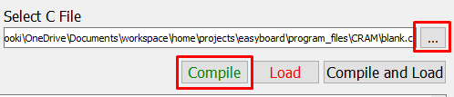

If compilation fails, check your code is valid.

# Load

To load a file, first open a HyperTerminal window by clicking ‘Open HyperTerminal’:

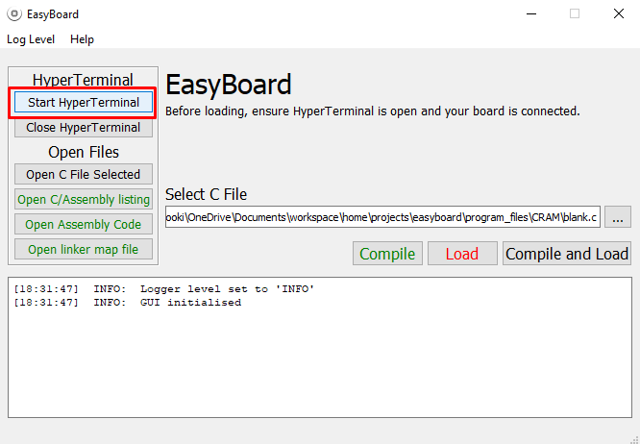

Setup the HyperTerminal using the configurations detailed in your course’s learning materials.

Now press the load button:

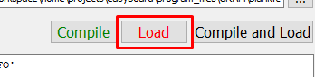

You will then have a failsafe prompt pop-up to remind you to check everything is in order. Press the reset button on your board, ensure HyperTerminal is open, then press ‘OK’ on the prompt.

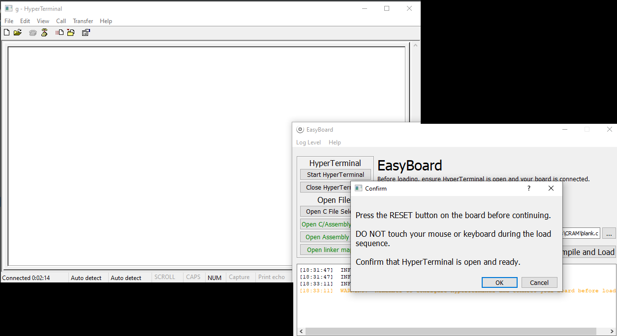

|  |
| --- |
| **IMPORTANT NOTICE**  **DO NOT touch mouse or keyboard during load sequence**. The program simulates keyboard presses to quickly load the file through HyperTerminal. If you change tabs, these key presses may continue and you may alter other apps or data on your PC. Just hang tight for a few seconds until your see the file loading (arrows being writing across the terminal: ‘>>>>>>>>>’) |

# Open Files

You can open files generated during compilation and your C file selected from the ‘Open Files’ pane.

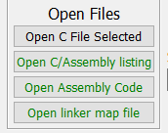

# Log Level

The log level menu options allow you to modify the logger output of the tool. For standard use, this should be set to ‘INFO’.

# Report Bugs

Please report any bugs via email with a screenshot (if applicable), to the tool maintainer:

[c014760h@student.staffs.ac.uk](mailto:c014760h@student.staffs.ac.uk)